i. ABSTRACT:

In this paper, I will elaborate the Token economics model of the Setheum Network. After going through this paper, the reader will understand the tokens and derivative commons, technicalities and issuance models of the BoE (Blockchain of Everything) Ecosystem, from the Functions of base tokens to the Parachain Auctions / Initial Parachain Offering (IPO), Monetary Regime, Token Symbols and the Initial Liquidity Injection.

ii. CONTENTS:

1. Key Functions of the Native Tokens
2. Tokens and Commons
3. SETT Token Econometrics
4. Issuance Model - Halving, Max. Supply, SettCard, SettPay and ROI
5. Monetary Policy
6. Fiscal Regime
7. Initial Minting and Issuance of DNAR:
8. Treasury Governance
9. Bridge Parachain Auction - IPO
10. Issuance of DNAR Tokens as IPO Reward
11. Initial Liquidity Injection
12. Distribution of DNAR Tokens to Other Parties
13. The Setheum Ecosystem
14. Key Functions of the Native Tokens

The DNAR is the native token of Setheum Network. The DNAR serves Seven (7) key functions in the Setheum Network:

1.1 Utility

The DNAR is the native fee token for the Network fees on the Setheum Network and is required to run the Network for all network activities. Transactions are issued in ***ꞨSETTCoin***, all other network activities are utilized by the native ***DNAR in Setheum.***

1.2 Staking

The DNAR is also utilized in staking for collators and validators and staking for oracles. DNAR is required to run a staking node on the network and earn DNAR staking rewards.

1.3 Liquidity

The DNAR can be used for liquidity staking on the Setheum Network to earn jDNAR liquid tokens and still earn staking rewards at the same time spending & ***trading*** the jDNAR.

1.4 Reserve Token

The DNAR is the Reserve Token of the SERP (Setheum Elastic Reserve Protocol), SETT tokens are backed by the DNAR elastically using the PES (Price Elasticity of Supply) algorithm.

1.5 Exchange Medium

The DNAR is used as the base currency and exchange medium for certain non-mainstream assets in the Setheum Built-In DEX - SettInDEX, similar to BNB in Binance.

1.6 Market Value Unit

The DNAR is used as the market capitalization unit of the assets, all assets are converted into voting power according to the price of DNAR, similar to ETH/ERC20.

1.7 Vesting

DNAR may have a lock placed on them to account for vesting funds. Like other types of locks, these funds cannot be transferred but can be used in other parts of the protocol such as voting in governance or being staked as a validator or nominator.

Vesting funds are on a linear release schedule and unlock a constant number of tokens at each block. Although the tokens are released in this manner, it does not get reflected on-chain automatically due to the fact that locks are [lazy](https://wiki.polkadot.network/docs/en/learn-DOT#lazy-vesting) and require an extrinsic to update.

There are two ways that vesting schedules can be created.

* One way is as part of the genesis configuration of the chain.
* A second way is through an extrinsic type available in the Vesting pallet, vested_transfer. The vested transfer function allows anyone to create a vesting schedule with a transfer of funds, as long as the account for which the vesting schedule will be created does not already have one and the transfer moves at least MinVestedTransfer funds, which is specified as a chain constant.

Vesting schedules have three parameters, locked, per_block, and starting_block. The configuration of these three fields dictate the amount of funds that are originally locked, the slope of the unlock line, and the block number for when the unlocking begins.

#### ***Lazy Vesting***

Like [simple payouts](https://wiki.polkadot.network/docs/en/learn-simple-payouts), vesting is *lazy*, which means that someone must explicitly call an extrinsic to update the lock that is placed on an account.

* The vest extrinsic will update the lock that is placed on the caller.
* The vest_other will update the lock that is placed on another "target" account's funds.

These extrinsics are exposed from the Vesting pallet.

1.8 Governance

The DNAR serves as the Proof of Stake Consensus standard in Setheum, the higher the number of votes, the greater responsibility in generating blocks and safeguarding consensus, also used as collateral and voting power for Chain Governance.

As a governance token, DNAR tokens provide their holders voting rights in Treasury Governance, Council Member Elections, Referenda, Network Up-grade, Risk Management et al, i.e. adjustment of Key Risk Parameters, such as Stability Fee, Liquidation Ratio, and Collateral Type.

1. Tokens, Symbols and Commons

* ***DNAR (£x)***: The Native Token of ***Setheum*** is the ***DNAR*** (Plural is ***DNAR*** /***Dinar***/). The maximum supply of the ***DNAR*** token is £x258,000,000 ($£x$ 258 million Dinar).
* ***Page (p)***: The smallest unit of a ***Dinar (£x)*** is a Page, the plural is “Pages”.***£x****1 DNAR = 10,000,000 pages.*
* ***SETT (Ꞩ)***: Also called the “***Settcoin***” or “***Sett coin***”. The Stablecoin Token of ***Setheum*** is the ***SETT*** (Plural is ***SETT*** /***Sett***/). The maximum supply of the ***SETT*** token is elastic, the ***SETT*** token is backed by the ***DNAR*** in Setheum.
* ***jTokens*** (***j****Tokens*): Also called the “***jettToken***”. The jTokens are the liquid tokens, the synthetic tokens, the margin tokens, et al.. The jTokens are the jSETT, jEUR, jAAPL, jTSLA, jBTC, jDOT, jETH, jSAR, jCNY, et al.

The jSETT token is the token that could be minted by locking any other tokens i.e. DAI, ETH, DOT et al.

* The jTokens are of two (classes):

1. ***The Synthetic Tokens:*** These are the tokenized synthetic assets on SettIndex, i.e. jAAPL (AAPL Apple stocks), jTSLA (jTSLA Tesla stocks), jEUR (jEUR Euro), et al.
2. ***The jSETT Tokens:*** These are the jSETT Tokens. Generated from locking inter-chain tokens like the DOT, KSM, DAI, USDC, ETH et al, as collateral to mint the jSETT stablecoin.
3. ***The Liquidity Staking Tokens:*** These are the jTokens generated by locking inter-chain tokens like the DOT, KSM, DNAR, ETH et al, as staking power to stake on their various networks and earn staking returns while the jTokens are minted for liquidity like the jDOT, jKSM, jDNAR, jETH et al.

* SettTokens (***Ꞩ****Tokens*): The ***SettTokens*** are the ***34*** fiat-pegged stablecoins in the ***SETT*** basket token. Prototokens are any token that is minted from a basket of tokens that contains that token and other prototokens like it or unlike it. The Prototokens in Setheum are ***ꞨTokens (SettTokens), and their base token is the ꞨCoin (SettCoin / SETT).***

The ***Ꞩ****Tokens (*SettTokens*)/Prototokens* are:

1. *ꞨUSD*
2. *ꞨGBP*
3. *ꞨCNY*
4. *ꞨJPY*
5. *ꞨSDR*
6. *ꞨEUR*
7. *ꞨSAR*
8. *ꞨNGN*
9. *ꞨKWD*
10. *ꞨBHD*
11. *ꞨOMR*
12. *ꞨJOD*
13. *ꞨGIP*
14. *ꞨKYD*
15. *ꞨAUD*
16. *ꞨCHF*
17. *ꞨCAD*
18. *ꞨBND*
19. *ꞨAED*
20. *ꞨSGD*
21. *ꞨLYD*
22. *ꞨNZD*
23. *ꞨGHS*
24. *ꞨBGN*
25. *ꞨBAM*
26. *ꞨAWG*
27. *ꞨFJD*
28. *ꞨDKK*
29. *ꞨMYR*
30. *ꞨZAR*
31. *ꞨSEK*
32. *ꞨMAD*
33. *ꞨTND*
34. *ꞨQAR*

3. SETT Token Economics - SERP

The Setheum Elastic Reserve Protocol (SERP) is the protocol responsible for the elastic supply of ***SETT(Ꞩ)*** and ***SettTokens (ꞨToken).***

The supply of ***SETT(Ꞩ)*** and ***SettTokens (ꞨToken)*** is based on the PES (Price Elasticity of Supply) Algorithm,

Elasticity is a proportionate change in one variable over the proportionate change in another variable:

Elasticity = $\frac{\%ΔQS}{\%ΔP}$

Where ***QS*** is the quantity and ***P*** is the Price, representing the %Change in Quantity / %Change in Price.

* If the price of DNAR increases by 10%, and the supply increases by 20%. We say the PES is 2.0.
* If the price of DNAR falls 12% and the quantity supplied falls 2%. We say the PES = $\frac{2}{12}$ = 0.16

${SETT(Ꞩ)}^{PES}$*= $\frac{\%Δ({QS}_{£x} + {QS}_{€x})}{\%ΔP(£x + €x)}$ = $SETT(Ꞩ)$ new*

The impact that a price change has on the elasticity of supply also directly impacts the elasticity of demand.

The price elasticity of supply (PES) is the measure of the responsiveness in quantity supplied (QS) to a change in price for a specific good (% Change QS / % Change in Price). There are numerous factors that directly impact the elasticity of supply for a good including stock, time period, availability of substitutes, and spare capacity. The state of these factors for a particular good will determine if the price elasticity of supply is elastic or inelastic in regards to a change in price.

The price elasticity of supply has a range of values:

* PES > 1: Supply is elastic.
* PES < 1: Supply is inelastic.
* PES = 0: The supply curve is vertical; there is no response of demand to prices. Supply is “perfectly inelastic.”
* PES = ∞ (i.e., infinity): The supply curve is horizontal; there is extreme change in demand in response to very small change in prices. Supply is “perfectly elastic.”

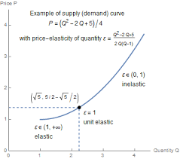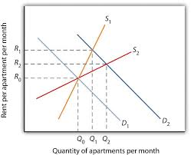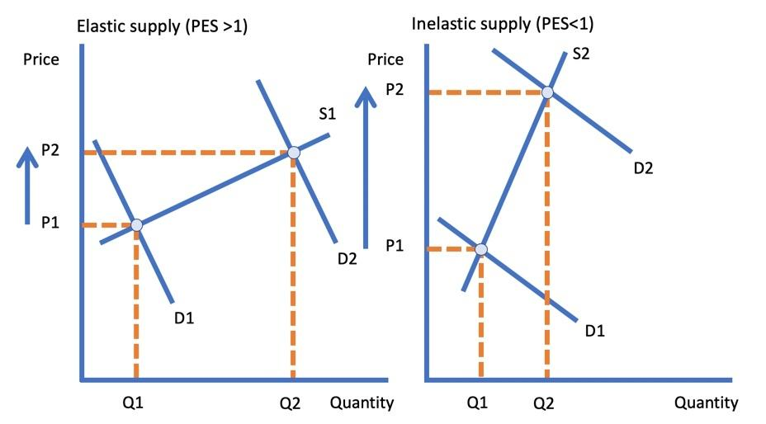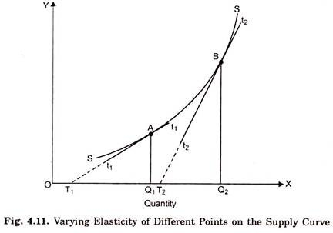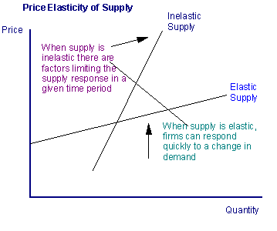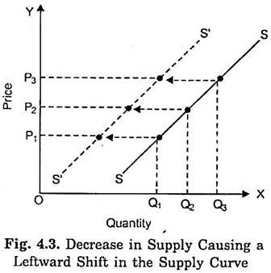

* If supply is elastic, an increase in demand will cause only a small rise in price, but a significant increase in demand.
* If supply is inelastic, an increase in demand will cause a large rise in price but only a small increase in demand.

The SETT is Elastic, and so an increase in the demand of SETT will result in a small rise in the price of SETT and a significant increase in demand. But because the SETT is backed by the DNAR - which is inelastic in supply, the increase in demand of DNAR will result to a large rise in price of DNAR, and that results in an increase in the supply of SETT that will be issued as discounts to SettPay and SettCard users. The supply of the SETT is relative to the demand and rise in price of the DNAR.

4. Issuance Model

Halving, Max. Supply, SettCard, SettPay and ROI

The issuance of SettTokens will be distributed to SettPay, as discounts for ecommerce apps and websites, and as discounts for all SettPay users. And will also be distributed to SettCard - SettPay’s Visa Card for integrating with traditional finance and other traditional eCommerce markets.

The SETT Issuance Model is Elastic, and so an increase in the demand of SETT will result in a small rise in the price of SETT and a significant increase in demand. But because the SETT is backed by the DNAR - which is also elastic in supply, the increase in demand of DNAR will result to a rise in the price of DNAR, and that results in an increase in the supply of SETT that will be issued as discounts to SettPay and SettCard users while an increase in the price of SETT over it’s peg will also result in an increased supply in Sett, 50% of the newly minted SETT will go to the validators of the network to buy back DNAR.

The supply of the SETT is relative to the demand and rise in price of the DNAR. The supply of ***SettTokens (ꞨToken)*** are reliant on the supply of the ***SETT coin (Ꞩ)***.

* ***The maximum supply*** of the ***DNAR*** is ***258,000,000 coins*** ($£x$ 258 million Dinar)***.*** The DNAR will be mined via staking with PoS (Proof of Stake) based on the NPoS (Nominated Proof of Stake) algorithm provided by the Polkadot and Substrate team for Substrate chains.
* ***The mining/staking rewards*** (minting of new coins/blocks) will be ***30% ROI (Return On Investment)*** and the issuance of the DNAR tokens will halve every 24 months. And that will drastically increase the Demand and Price of the DNAR tokens. The drastic increase in the Demand and Price of the DNAR will result in rising SETT prices and minting new SETT coins for distribution in the Sett Economy.

5. Monetary Policy

The existential objective of a stable currency is to retain its purchasing power. Given that most goods and services are consumed domestically, it is important to create cryptocurrencies that track the value of local fiat currencies. Though the US Dollar dominates international trade and forex operations, to the average consumer the dollar exhibits unacceptable volatility against their choice unit of account.

Recognizing strong regionalism in money, ***SETT coin (Ꞩ)*** aims to be a family of cryptocurrencies in an “***STP Standard***” (‘***Setheum Tokenization Protocol’ Standard***) that are each pegged to their respective equivalents. ***SETT coin (Ꞩ)*** is the ‘basket token’ (a token which is made up of all the tokens on the ***STP258*** Standard) of the ***Setheum Finance*** and all the stablecoins on that protocol are defined by the ***Sett standard***. (So when I say ***Sett token***, I might mean any of the tokens of the ***Sett family*** and when I say ***Settcoin*** or ***Sett coin*** I might mean the base ***SETT coin (Ꞩ).***

The ***STP258*** standard contains the major global fiat currencies that can be atomically swappable in the Setheum Reserve using the ***SERP (Setheum Elastic Reserve Protocol)*** on the Setheum Network.

Unlike today’s popular monetary policies, it is a unique one in the ***Setheum Reserve***, first of all the Monetary Aggregates are extended and incorruptible in Setheum Finance, so setheum does not compute ***High-Powered Money (HPM)*** into ***SETT(Ꞩ)***, which is basically the multiplication of the ***Monetary Base*** (MB or M0) with ***Fractional Reserve Banking***.

Setheum mints Sett through an elastic money supply relying on PES, so the amount of Sett to be minted is proportional to the pairing of Dinar versus the corresponding Sett currencies relative to its ***fiat peg*** and its market cap.

Once the system has detected that the price of a Sett currency has deviated from its peg, it must apply pressures to normalize the price. Like any other market, the Setheum Financial market follows the simple rules of supply and demand for a pegged currency.

So, contracting money supply, all conditions held equal, will result in higher relative currency price levels. That is, when price levels are falling below the target, reducing money supply sufficiently will return price levels to normalcy.

Expanding money supply, all conditions held equal, will result in lower relative currency price levels. That is, when price levels are rising above the target, increasing money supply sufficiently will return price levels to normalcy.

Of course, contracting the supply of money isn’t free; like any other asset, money needs to be bought from the market. Central banks and governments shoulder contractionary costs for pegged fiat systems through a variety of mechanisms including intervention, the issuance of bonds and short- term instruments thus incurring interest expenses, and hiking of money market rates and reserve ratio requirements thus losing revenue. Put in an easy way, central banks and governments absorb the volatility of the pegged currencies they issue.

In the short term, validators absorb ***SETT(Ꞩ)*** contraction costs through validating power dilution.

This will increase the price of the tokens, thus providing SETT minting and distribution to the entire ***SettEconomy***. Setheum Finance would allow the Validators to mine those locked tokens again as the demand increases and the supply of SETT increases, then the economy would find a balance point for constant minting and contraction of DNARand SETT..

In the short term, validators absorb ***SETT(Ꞩ)*** contraction costs through validating power dilution. During a contraction, the system mints and auctions more validating power to buy back and burn ***SETT(Ꞩ)***. This contracts the supply of Sett until its price has returned to the peg, and temporarily results in mining power dilution.

As minting and contraction take place, the supply is distributed accordingly in ***SETT(Ꞩ)***, and Setheum Finance will provide a way to atomically swap ‘***ꞨSETT***’ for any of the ***ꞨTokens*** in the family/basket on stablecoins contained in the ***STP258 Standard***.

So, basically, ***ꞨSETT*** mints tokens according to the preference of the user, you can choose to use ***ꞨUSD(SettUSD)*** or ***ꞨSAR(SettSAR)***, or ***ꞨNGN(SettNGN)*** or any of the 34 ***ꞨTokens*** and can swap that back into the basic ***ꞨCoin (SETT)*** via the Atomic Shifter Tunnel (basically using ***Substrate’s atomic swap*** pallet). These tokens minted by SETT, are called “***Prototokens***”, because the are tokens derived from the supply of a basket token in a blockchain on the network, that is backed by the main staking token of the Setheum Network. So,it’s a complex but efficient mechanism

.

So, if Alice has ***$100 USD*** worth of ***ꞨSETT***, Alice could mint ***Ꞩ100USD (100 SettUSD)*** or it’s equivalent of ***ꞨSAR(SettSAR),*** or ***ꞨNGN(SettNGN)***, or any one of the thirty-four (34) available ***ꞨTokens*** (initial plan was to have 100 ***ꞨTokens pegged to 100 fiat currencies***.

But now due to heavily thought through ***Strategic Economic Research***, we can only have ***34 strategic ꞨTokens***, more ***ꞨTokens*** could be added to the ***STP 258 Standard*** later through the ecosystem voting process and has to pass through the congress, when a vote passes the system upgrades on-chain with the on-chain governance and upgrade mechanisms).

If the PES is 2.0 for DNAR: and the protocol supplied 4,000 SETT when the price was £30

Q. If the price increased from £30 to £36, what will be the new Q?

* QS increases by 6, therefore as a % 6/30 = 0.2 = 20%
* 2.0 = % change in QS /20
* 40 = % change in QS
* Therefore new Q = 4000 *140/100 = 5,600
* And so, 2800 SETT will be distributed as discounts and cashback on SettPay.
* And so, 2800 SETT will be distributed to the validators to buy back DNAR worth that amount for burning.
* Therefore the staking rewards will increase relative to the amount of DNAR burnt. So if 10 percent of DNAR was burnt, then the staking reward will increase by 10%, i.e. from 30% to 33%. This in turn further increases the price of DNAR.

Hence the supply and distribution of SETT as discounts and stimulus to the users of SettPay and SettCard.

In the mid to long term, validators are compensated with increased staking rewards. First, the system continues to buy back staking power until a fixed target supply is reached, thereby creating longrun dependability on available validating power, the system increases validating rewards afterwards by adding the locked ***DNAR*** to the validation and staking reward pool in the ***SERP***.

In summary, validators bear the costs of ***Ꞩ(Sett)*** volatility in the short term, while being compensated for it in the long-term. Compared to ordinary users, validators have a long-term vested interest in the stability of the system, with invested infrastructure, trained staff and business models with high switching cost.

The ***Contraction*** and ***Minting*** method in ***SERP***, is inspired by the Terra model of contraction and minting for price-stability. But ***SERP*** improves much on that. And the ***fiscal policy*** and ***staking rewards*** are processed uniquely on Setheum.

6. Fiscal Regime

Setheum Payment Protocol is basically the face of Setheum Finance, this is what validators, exchanges, DApps (E-Commerce platforms, payment platforms, Games, Streaming Apps, etc.) are required to communicate with in order to access newly minted Sett.

So when we talked about ‘Alice’ swapping or minting ***Ꞩ100USD***, we were referring to the Setheum Payment protocol in the background. This part of the Setheum Finance is responsible for distributing what comes from the Setheum Reserve (SERP), so all minted ***Ꞩ*** have to pass through this.

The main purpose of this is to provide the discounts on DApps That use it and, even wallets that are built on it will give users access to this massive reward, where if a user deposits Sett in that wallet Dapp, their account gets some more Sett when the value increases and more sett is minted.

This type of wallet can choose to have a reserve that stakes Dinar, and then distribute the rewards it gets from newly minted Sett to the users as a SignUp bonus or something like that, whatever they wish.

Similarly, Dapps can finally be free of charge for as long as the the DApp has a reserve that stakes and is built on the Setheum network, it can use the rewards of Ꞩ(Sett) it receives to pay its transaction fees, so this way DApps can be tested on the mainnet without having to pay from their initial capital. Even ICOs can benefit from this model. This opens up a lot more opportunities than I can actually imagine.

And we will support the Developers of Such DApps on the Setheum blockchain. We will create a Blockchain Fund to invest and offer grants to innovative DApps and Blockchains built on the Setheum Network, I personally am interested in the projects i just highlighted, I am willing to share ideas with the most innovative and charismatic developers, game designers, engineers, mathematicians, cryptographers, and students who are planning to propose intelligent projects on the Setheum Network.

Same way, an ecommerce site/platform can harness this beauty of Setheum to attract more users/customers with amazing discounts, the site can even have the type of reserve like that of the wallet I suggest, to direct discounts in whatever manner they wish. And these prototokens are also tradable like all other tokens on the Setheum Network and atomic swap between SettPrototokens and SETT BasketToken is also available, this swap process is also called “Atomic Shift” on Setheum, due to the nature of how the tokens are minted, SETT is put in, and the system burns it into newly minted ***Ꞩ(Sett)*** Prototoken/SettToken, and vice versa.

This takes place in a tunnel called the “Atomic Shifter” between the SERP and SettPay in Setheum Finance. So without SettPay, Sett Prototokens will not be minted from SETT, let alone distributed.

7. Initial Minting and Issuance of DNAR Tokens

Half (50 %) of the total supply of DNAR Tokens will be minted at the launch of the mainnet and stored in the Setheum Treasury Pool to be distributed to:[1]

* ***Setheum Team:*** ***30%*** will be reserved for the Setheum Team.
* ***Ecosystem Fund:*** ***2.5%*** will be reserved for the Ecosystem Fund (DS3 Fund managed and governed by the “Setheum Foundation”) for Ecosystem growth and development, ie. rewarded as grants and bounties et al.[2] The DS3 Fund also supports the Substrate, Polkadot and the entire Web3 Ecosystem.
* ***Setheum Investment Fund:*** ***2.5%*** will be reserved for the SIF in the SIF reserve for Diversification in foreign cryptocurrency investments, the SIF will function like a Public Investment Fund or Sovereign Wealth Fund for the Setheum Network.The SIF will invest in lucrative cryptocurrencies that have great potential, utility and liquidity. The SIF will be governed by the Council.

Some small amount of DNAR of the Ecosystem Fund’s reserve will be sold in public token sale event (ICO/IEO)

* ***Strategic Investors:*** ***10%*** of which will be distributed with discounts over the token sale price to the strategic investors i.e. Early Investors, SAFT, VCs.
* ***Network Participants:*** ***5%*** will be distributed to Validators, Collators and other network participants.

*DNAR distribution is subject to change.*

8. Treasury Governance

Network fees from the following sources are stored in the Treasury, which is under the governance of DNAR holders.

* ***Stability Fee:*** To close a CDP with outstanding debt of ***n*** jSETT, the CDP owner is required to pay ***s $∙$ n*** jSETT as Stability Fee, where ***s*** is the effective interest rate.
* ***Liquidation Penalty:*** All open CDPs are constantly monitored by the system. For each collateral type, a corresponding liquidation ratio is voted by DNAR holders, reflecting the amount of overcollaterization a CDP is required to meet to avoid liquidation.

Once the value of the CDP collateral has fallen below the requirement based on the liquidation ratio, the CDP becomes risky and is automatically liquidated by the system through a hybrid mechanism consisting of the built-in DEX (Settindex) and Collateral Auctions. In a Collateral Auction, a proportion of collateral is sold to cover the outstanding debt in the CDP, and a liquidation penalty of ***p $∙$ n*** jSETT, with any remaining collateral returned to the CDP original owners.

* ***Protocol Fees:*** Protocol fees include the DEX fee and the jDOT protocol fee.

9. Bridge Parachain Auction - IPO

We plan to launch our mainnet as an independent chain in the Web3 Polkadot Ecosystem and connect to Polkadot and Kusama through our bridge parachains on Parachain slots, to be leased from Polkadot, using DOTs (for our Setheum Network bridge parachain) to be crowdfunded.

A Candle Auction is utilized to sell the leasing right of Parachain slots. It is a mechanism designed for fairness - to prevent early sniping and provides higher chances of winning to bidders with higher valuation.

Since it will be a challenge to estimate private valuation distribution of bidders with private bidding strategies, and we plan to conduct a Crowdfund IPO (Initial Parachain Offering), that we will:

1. Start our DOT Crowdfund at time ***t − 30***.
2. Bid $F_{0}^{1}$, total fund collected for a 12-month lease of a Parachain slot, at time ***0***, the open time of the first Parachain slot auction.
3. Bid $F_{t}^{1}$, whenever total funds increase at time ***t < T***, before the close time ***T*** of the first Parachain slot auction.
4. After the retroactive close time ***t∗*** of the first Parachain slot auction is announced, if our last bid before ***t∗*** is successfully accepted, $F_{t∗}^{1}$ units of DOTs will be locked to lease the Parachain slot and the rest of $F_{T}^{1}$ − $F_{t∗}^{1}$ DOTs that are deposited into the crowdfund after ***t∗*** will be returned to their owners.
5. Distribute DNAR tokens as rewards to DOT owners who participate in our first Polkadot Bridge Parachain IPO successfully, to compensate their opportunity costs of having their DOTs locked for 12 months.

10. Issuance of DNAR Tokens as IPO Rewards

The DNAR tokens reserved as IPO rewards are planned to be distributed to IPO participants during the first leasing years. It is obvious that these DNAR tokens would be better distributed in a frequent small batches of distribution rather than in lump sums at the beginning of each round of Parachain lease, which would lead to sudden large shifts in DNAR supply causing unfavourable large price fluctuations as shown below.

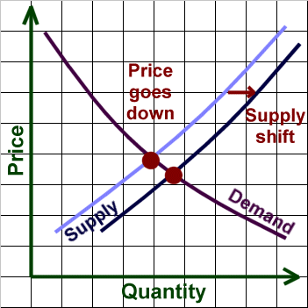

Thus, it is better that we release the IPO rewards in batches not at once.

We propose that all DNAR IPO rewards tokens planned to be distributed in each round are to be distributed to each successful IPO participant at every second, according to the proportion of their shares of locked DOTs and/or KSMs in the total number of locked DOTs, for less market fluctuation.

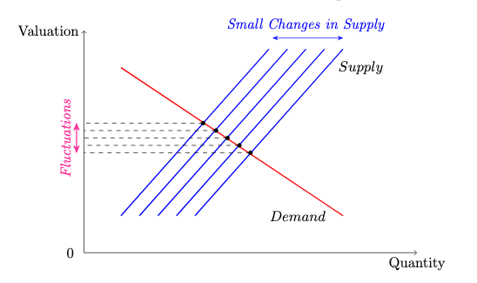

The image above is representing the distribution of DNAR tokens as IPO rewards to IPO participants. A little fluctuation in the price and a little less demand, but the demand will be restored to an even higher position and a rapid increase in price when the DNAR issuance halves, the staking rewards halve every 24 months (2 years).

11. Initial Liquidity Injection

Before the launch of the Setheum mainnet, a small proportion of DNAR tokens reserved in the Setheum Investment Fund’s Treasury will be available at public Token Sale events i.e. ICO, IEO, to inject initial liquidity to the network. DNAR tokens sold through public Token Sale events will be distributed to the participants immediately and are ready to be staked, traded et al at the launch of the Setheum mainnet.

12. Distribution of DNAR Tokens to Other Parties

DNAR Tokens distributed to other parties such as Strategic Partners, are not allowed to be traded for a fixed length of time (vesting schedule varies from 12 to 24 months after launch of mainnet) for market stability.

And remember, the DNAR supply halves every 24 months (2 years). So you don’t want to sell your potential of doubling your investments & profits.And remember, SettIndex gives you the capability to earn with liquidity staking with both DNAR and also mint jTokens as you earn staking rewards of 30% ROI.

13. The Setheum Ecosystem  
The Setheum ecosystem consists of the following Products, Services and Interoperability ecosystem:

* ***Setheum Network:*** The Network, the interoperable blockchain with a Bridge Parachain on Polkadot.
* ***SettIndex:*** The Setheum Built-In DEX, margin trading, money market, synthetic assets et al.
* ***SettPay:*** SettPay users will get discounts on their purchases processed with the SettPay App anywhere, everywhere, even where the SETTPay Gateway is not the main Gateway.
* ***SettCard:*** Interoperability with the Open World, SettCard owners can purchase on SettPay gateways and get discounts through the SettPay Gateway from the SERP. Makes it easy to spend SETT and other crypto in traditional financial markets and ecommerce.
* ***Kusama Network:*** Connect to Kusama.
* ***Polkadot Network:*** Bridge Parachain on Polkadot for more seamless interoperability with Setheum Network.
* ***Ethereum:*** EVM and ERC20 on Setheum for Ethereum Interoperability.
* ***Bitcoin:*** Interoperability with the Bitcoin Blockchain.

1. *The distribution plan is subject to change.*
2. *The DS3 Fund also supports the Substrate, Polkadot and the Web3 Ecosystem especially concerning projects building on or connecting to the Setheum Network.*